SOFTWARE EGINEERING MIDTERM
Abhimanyu Sood 23BAI1352

Q7
Airline reservation system for flight booking cancellation and seat allocation system -Use Case diagram

ACTORS -
- Passenger

Books flights, cancels bookings, selects seats, check prices, enter details, change seats, reschedule flights, check seat availability, select food preferences, makes payments.
- Reservation Agent
Assists passengers in booking, cancellation, seat allocation, making payments, rescheduling flights.
- System Administrator
Manages flight schedules, seat availability, system maintenance, list fares, processes refunds
- Payment Gateway (external system)
Handles payment transactions, Handles Refunds
- Flight Database (external system)
Stores flight details, seat availability, booking info, food preferences

Use Cases:

1. Flight Booking
- Passenger/Agent selects flight and seats.
- Passenger/Agent checks prices.
- Passenger/Agent enters personal details.
- Passenger/Agent enters food preferences.
- Passenger/Agent makes payment (through Payment Gateway).
- System confirms booking and generates ticket.

2. Seat Allocation
- Passenger selects or changes seat during booking.
- Agent allocates or changes seat on behalf of passenger.
- System updates seat availability in real-time.

3. Booking Cancellation
- Passenger requests cancellation of booking.
- Agent processes cancellation request.
- System updates seat availability.
- System processes refund via Payment Gateway.

4. Flight Schedule Management (Admin Use Case)
- System Administrator adds/updates/deletes flight schedules.
- System Administrator manages seat inventory per flight.

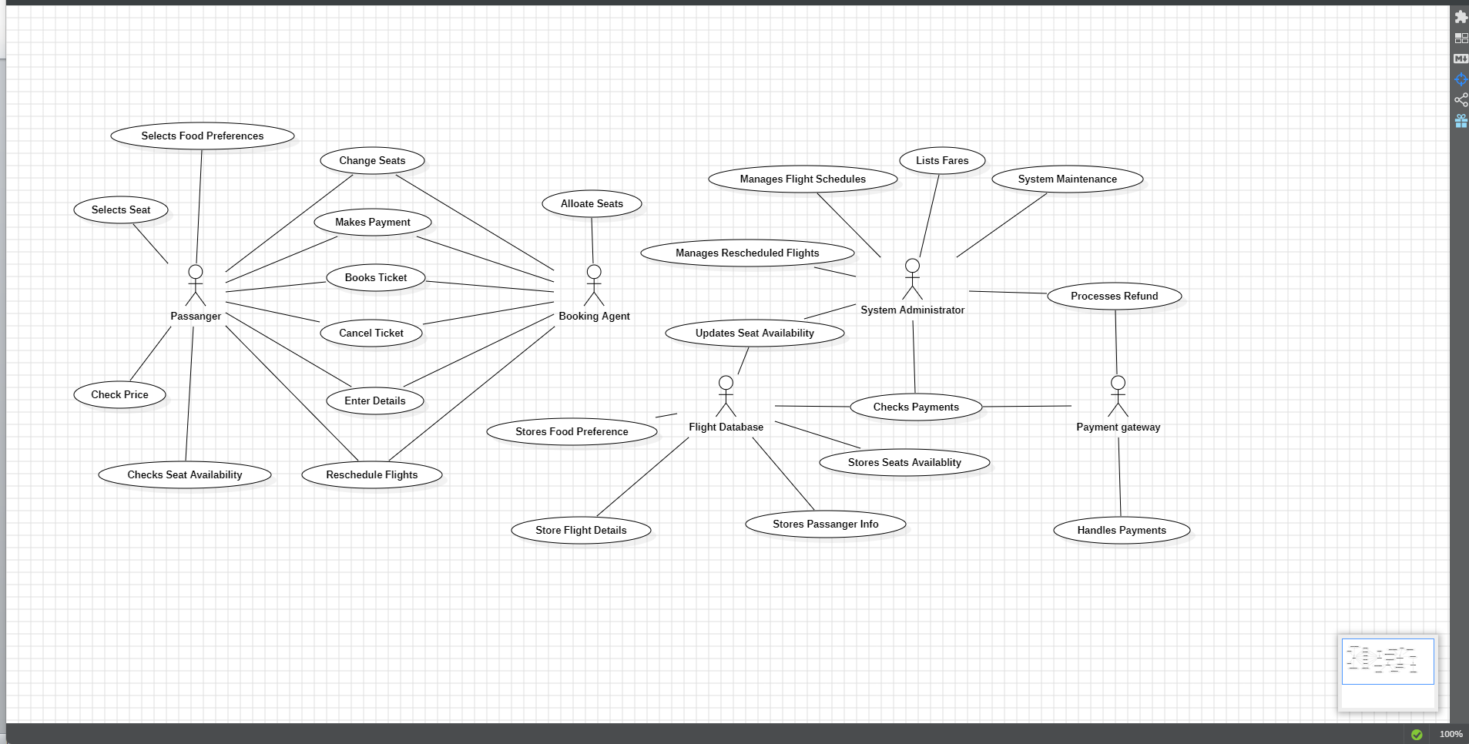

The Passenger can search for the flight, check prices, check seats available, book picket, enter detail, select food preference, make payment, select seat and can reschedule flight.

The Booking Agent can book ticket, make payment, allocate seat, reschedule flight or cancel flight for the passenger.

The System Administrator is responsible for system maintenance; manage flights, list fares, process refunds with the help of payment gateway.

The Flight database is responsible for storing data like storing personal data of passenger, flight details, seat availability and updates upon every booking made and stores food preferences.

The payment gateway handles payments and handles refunds.

